Milestone 3 Narrative – Enhancement Two: Algorithms and Data Structures
Karina Washington
Southern New Hampshire University
CS 499
November 19th, 2025

Artifact Description

The artifact I selected for Enhancement Two is the GPIO Morse Code Embedded System originally created for CS-350: Emerging Systems Architectures and Technologies in Fall 2024. This project was written in C for the Texas Instruments CC3220x LaunchPad using TI-RTOS. The purpose of the original artifact was to flash LEDs in Morse code using GPIO interrupts and a periodic timer. The program implemented a simple state machine to blink the SOS distress signal
Justification for Inclusion I selected this artifact because it demonstrates essential competencies in algorithms, data structures, and embedded system control, which directly align with the second required enhancement category for the capstone. This artifact represents my experience designing low-level, efficient, hardware-responsive algorithms that manage timing, state progression, and interrupt-driven behavior. Enhancing this project also allowed me to build deeper algorithmic structure into the software. As Knuth famously wrote, “An algorithm must be seen to be believed” (Knuth, 1997, p. 3). By redesigning the logic into a fully structured state machine supported by clear data structures, I turned an originally simple blinking program into a demonstrably robust algorithmic system.
Enhancement Overview Several major enhancements were implemented to showcase algorithm design and data structure usage:
1. Structured Data Using Arrays of Custom Types
The original code included repetitive timing logic embedded directly inside conditionals. I redesigned this by creating structured MorseStep arrays, where each element stores the LED, its on/off state, and its duration in timer cycles. This converts the Morse code sequence into a data-driven structure, improving clarity and modularity.

2. Expanded and Generalized State Machine Logic
I expanded the state machine to support two Morse messages—SOS and OK—and added interrupt-driven switching between messages using button input. The enhanced state machine algorithm now handles:
- Step sequencing
- Duration control
- LED activation
- Message transitions
- Automatic looping
This demonstrates a stronger mastery of algorithmic flow control.

3. Improved Timer-Based Algorithm
I replaced duplicated timing behavior with a unified duration counter managed by a periodic timer callback. Each interrupt advances the algorithm by exactly one logical step, improving accuracy and efficiency.

4. Scalability for Additional Messages
By restructuring the program into generalized data structures, additional Morse sequences can be added without rewriting logic, showing the use of extensible algorithmic techniques.
Flowcharts Before and After Enhancement
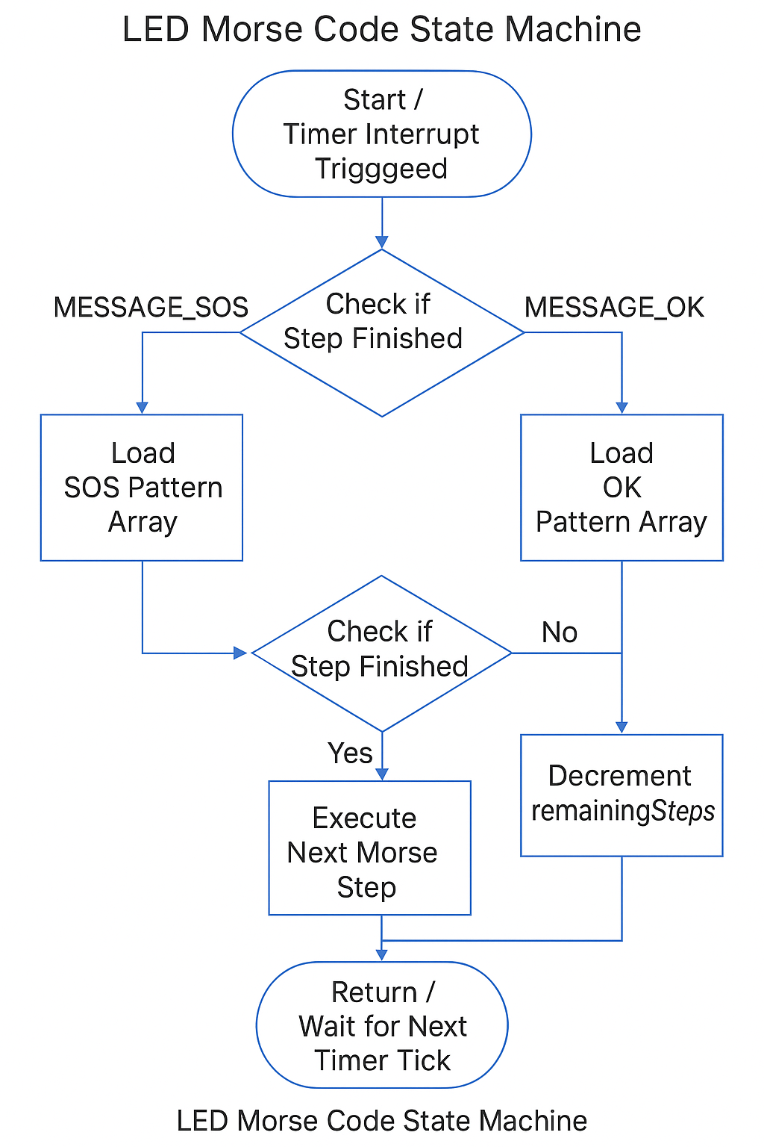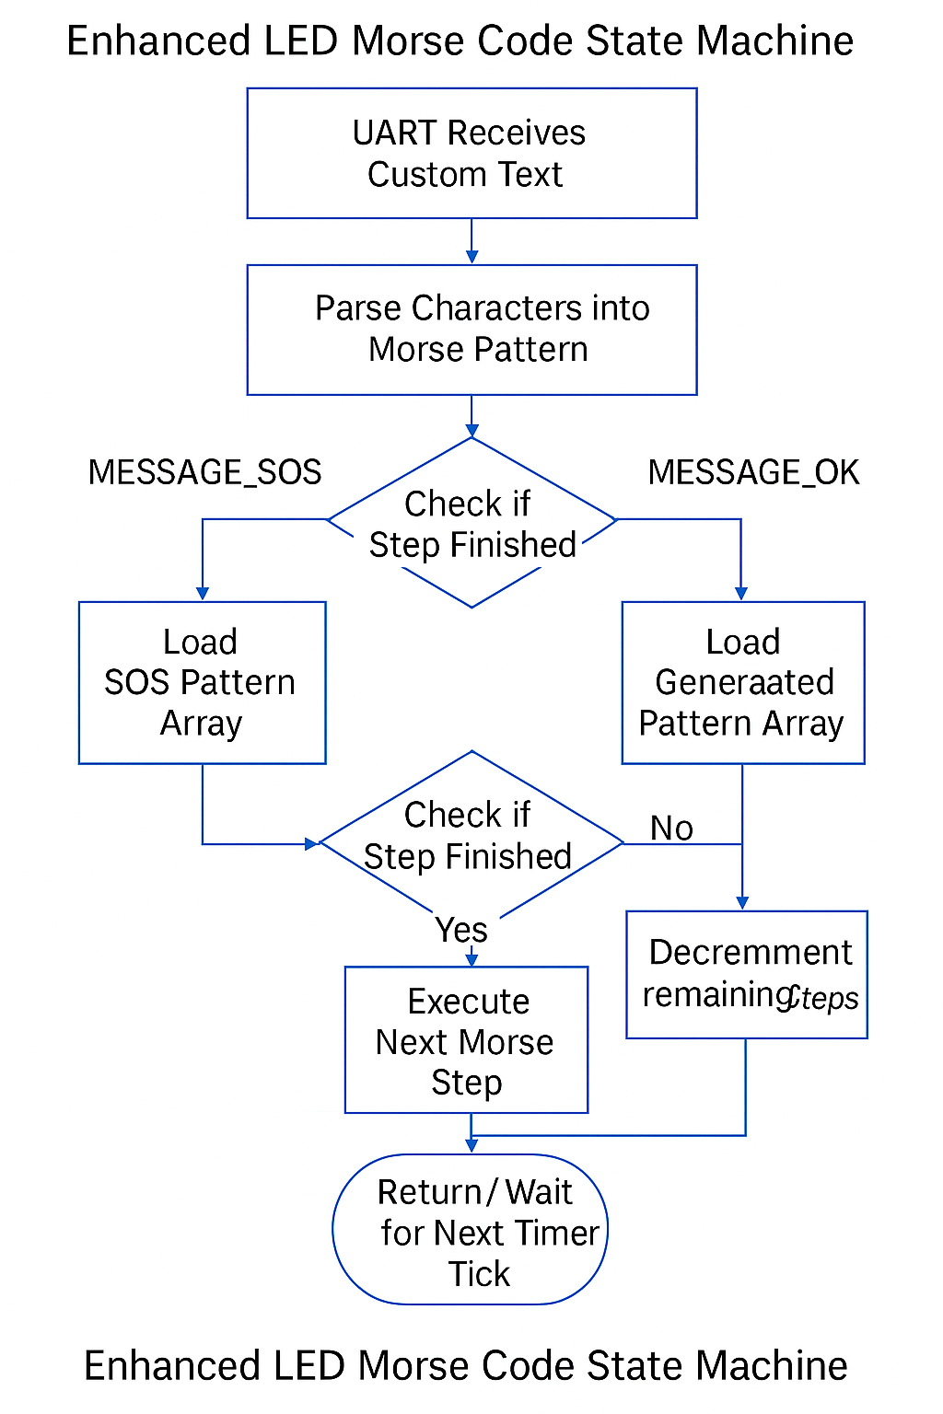

Connection to Course Outcomes

This enhancement aligns strongly with multiple computer science outcomes:
Algorithmic Principles and Data Structures: The new design transforms the program into a structured, algorithm-driven system using arrays, loops, counters, and a formal state machine framework.

Software Engineering Techniques: The enhanced artifact uses modular functions, structured design, and reusable logic consistent with best practices in embedded software development.

Security and Reliability: Using volatile variables for interrupt-safe communication and ensuring deterministic behavior under real-time constraints demonstrates a security-aware and reliability-focused mindset.

Reflection on the Enhancement Process
Enhancing this artifact helped me understand embedded algorithms more deeply, especially the challenges of timing precision and interrupt coordination. Converting the Morse sequence into a data structure required careful attention to how each step interacted with the timer. One challenge was ensuring the state machine looped seamlessly without skipping or duplicating steps. Testing with the physical Launchpad reinforced the importance of designing predictable, safe behavior under hardware constraints.
This enhancement met the goals I outlined earlier in the course by expanding the artifact’s complexity, improving algorithmic structure, and demonstrating skills essential for embedded systems programming.

Pictures of the Chip and Morse Code:
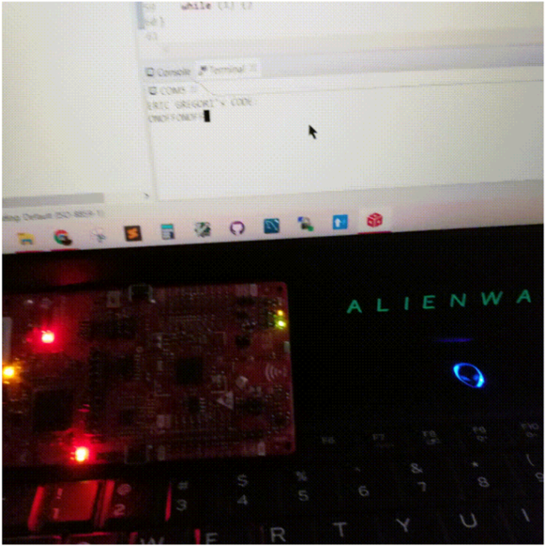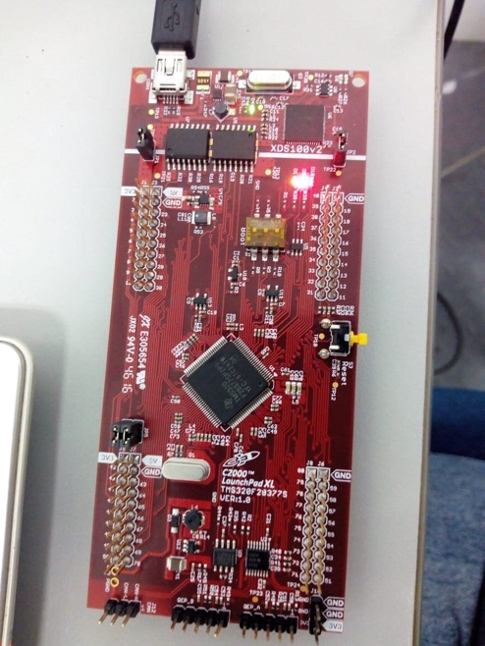

Reference
Knuth, D. E. (1997). The art of computer programming: Volume 1: Fundamental algorithms
(3rd ed.). Addison-Wesley.

